* **Name of the Activity**: National Seminar on "Anubad Sahitya"
* **Date of the activity**: 30.03.2023 & 31.03.2023
* **Organizing Department**: Dept. of Bengali, Chakdaha College
* **Speakers:**
  + Arundhuti Bhattacharya, Ex-professor of Bangalore University
  + Dr. Mrinmay Pramanik, Calcutta University
  + Dr. Munmun Chattapadhyoy, Gurudas College
  + Prof. Jyotsna Chattapadhyoy, Rabindrabharati University,
  + Prof. Uday Narayan Singha, Amity University
  + Dr. Ashis Khastogir, Retired Professor
  + Dr. Amaresh Mondal, Bidhannagar Govt. College
* **Number of Participants**: 29
* **Photographs of the Seminar:**

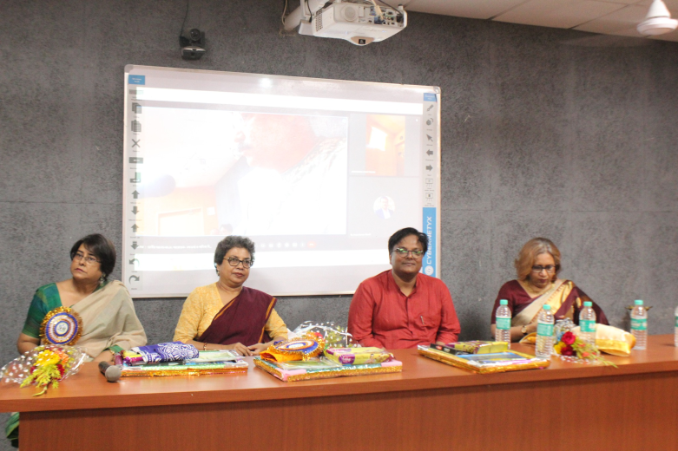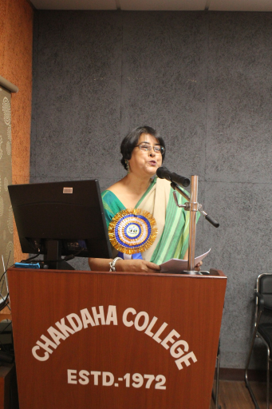

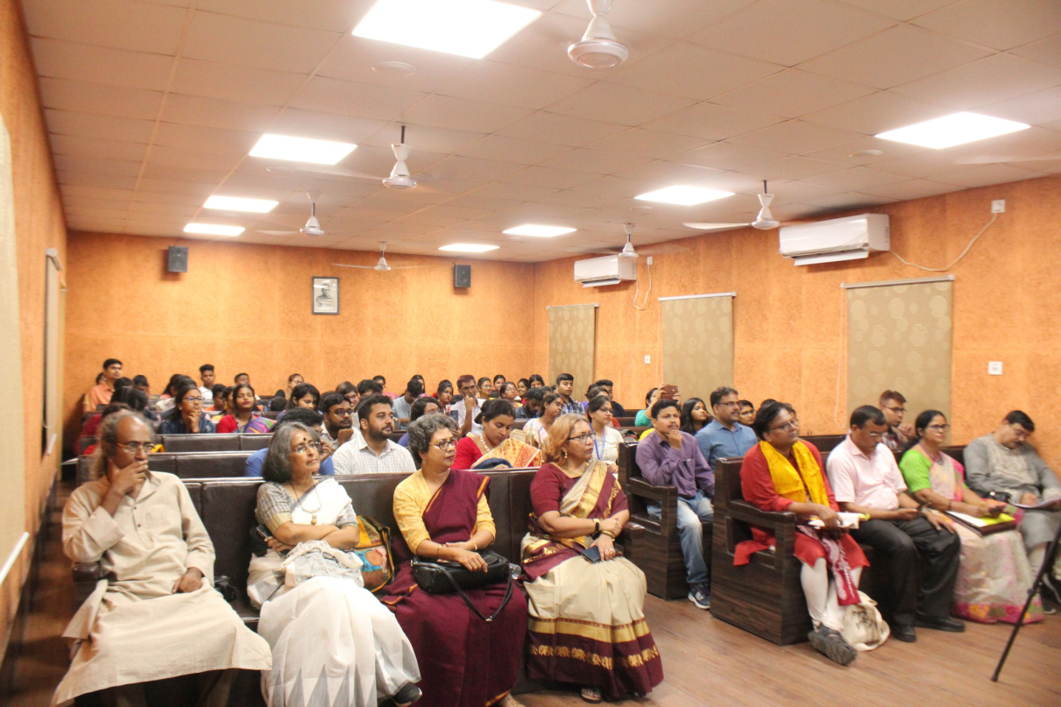

**Attendance:**

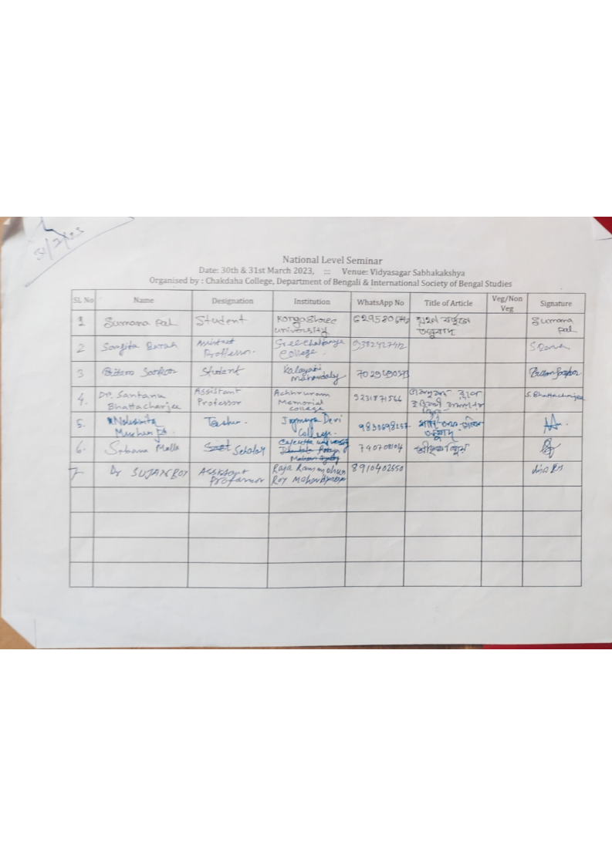

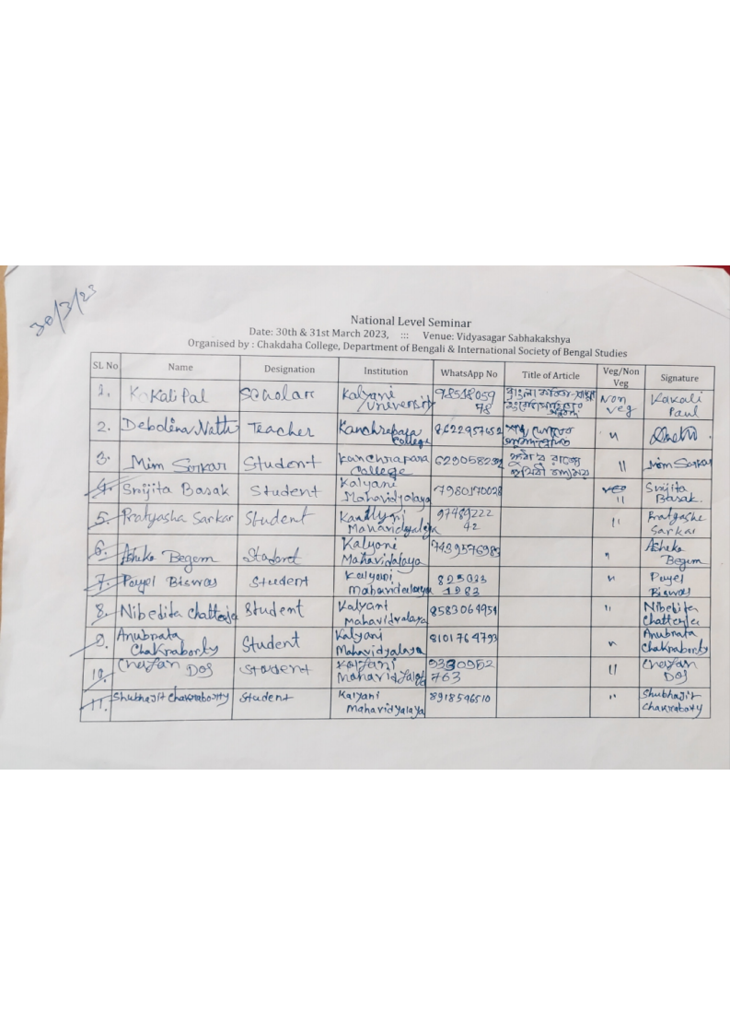

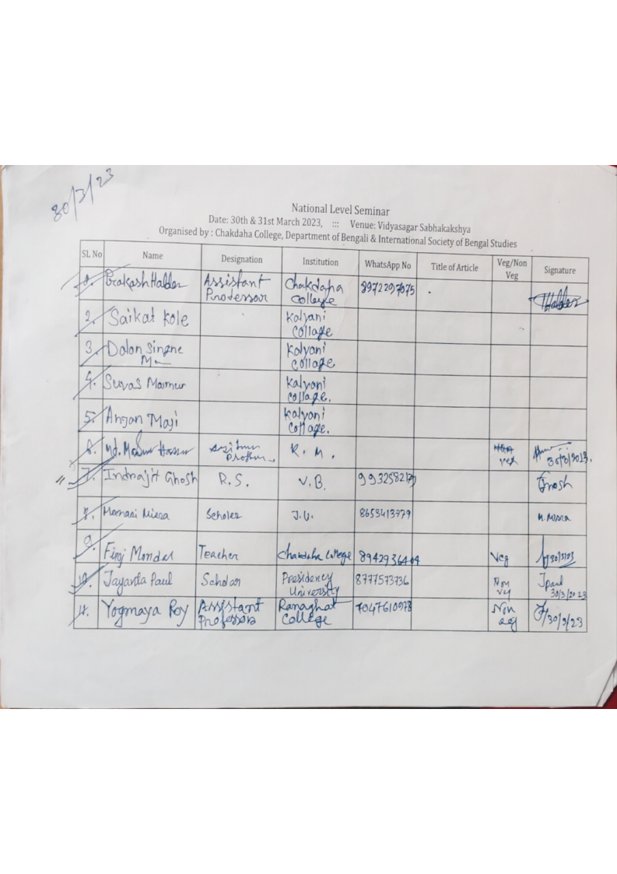

***Relevant Web Link:***

<https://www.facebook.com/media/set/?vanity=chakdahacollegeoffice&set=a.619180163556085>